Del Norte County
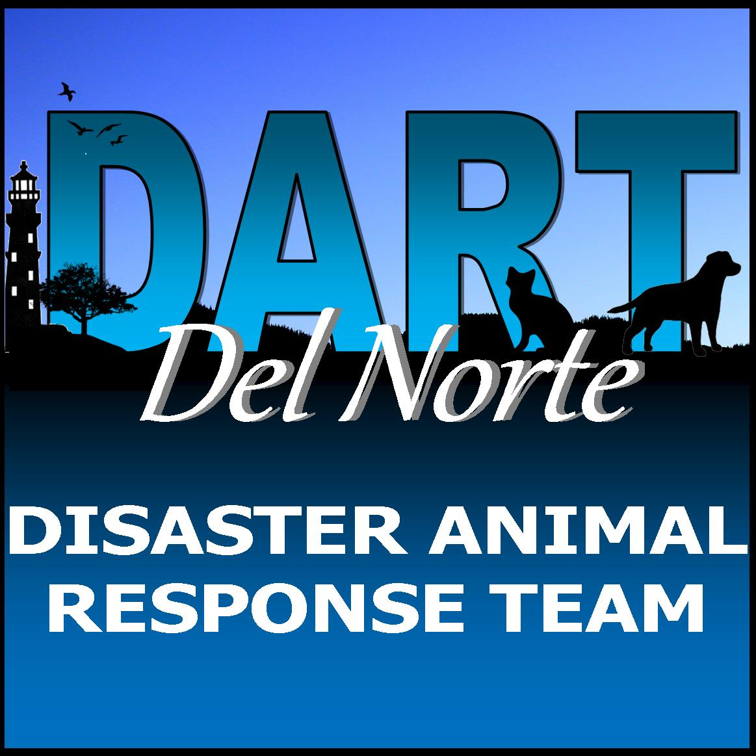

Emergency Planning for Your Pet

Are You Prepared?
We live in an area that is prone to certain natural disasters, such as earthquakes, tsunamis, wildfire, or floods. Emergencies come in many forms and they may require anything from a brief absence from your home to permanent evacuation. Each type of disaster requires different measures to keep your pets safe. The best thing you can do for yourself and your pets is to be prepared. Leaving pets out of evacuation plans can put pets, pet owners, and first responders in danger.
When recommendations for evacuation have been announced by your local emergency management office, follow the instructions of local and state officials. For more information go to: http://preparedelnorte.com

If you have to Evacuate:

- DO NOT LEAVE YOUR PETS BEHIND. Pets are unlikely to survive on their own.

- Store emergency kits (for both you and your pets) and leashes close to an exit.

- Make sure all pets wear collars and tags with up-to-date identification.

- Always bring pets indoors at the first sign or warning of a storm or disaster. Pets can become disoriented and wander away from home during a crisis.

- Consider your evacuation route and call ahead to make arrangements for boarding your pet outside of the danger zone at the first sign of disaster.

- Use a rescue sticker alert to let rescuer know that pets are inside your home. Includes the types and number of pets in your household. If you have evacuated with your pets (and if time allows) write "EVACUATED" across the stickers so rescue workers don’t waste time looking for them.

- Take photos of you with your pet(s) in case you are separated. Keep copies in your wallet, phone, disaster kit, and give copies to friends who lives outside of your area.

Arrange a Safe Haven for your pets in the event of evacuation:
If you evacuate, take your pet. Remember, if it isn't safe for you, it isn't safe for your pets. Even if you try to create a safe place for them, pets left behind during a disaster are likely to be injured, lost, or worse.
- Ask friends and relatives outside your immediate area if they would be willing to take in your pet. Exchange keys with someone who can evacuate your animals if you are not home when disaster strikes. Make sure they know where the pets’ emergency supplies are located.

- Listen to the radio for information concerning local emergency shelter or foster care for pets. Del Norte County emergency services info provided below.

- If you are unable to return to your home right away, you may need to board your pet. A list of boarding kennels and facilities is provided in below. Keep a copy of the locations with your pets’ emergency supplies.

- Consider staying at hotels or motels outside of your immediate area that accept pets (a list is provided below). Keep a copy of the locations with your pets emergency supplies

"GO-BAGS"
Keep a PET PREPAREDNESS KIT (Go-Bag) handy for your pets. Make sure that everyone in the family knows where it is. Keep your pet’s essential supplies in a sturdy Go-Bag or container that is clearly labeled, readily accessible, and easy to carry. Documents, medications, and food should be stored in waterproof containers. Assemble a kit or include supplies for each animal in your household.
Items to consider keeping in or near your Go-Bag include:
___Food (your pet's regular food) for at least 1 week for each pet; rotate food every two months to avoid spoilage
___Water, rotate supply every two months
___Food and water bowls and a manual can opener
___Leash or harness, collar with identification tags; Temporary “write-on” identification tag
__A handout containing identification pet information for boarding or shelter info (example below)
__Photo of your pet/ID and a photo of you with your pet in case they get lost.
__A "lost animal" flyer in the event you get separated from your pet with the following information (example below)
  - Pet’s descriptive features (age, breed, color, and weight)
  - Microchip number
  - Your contact information (cell phone, work phone, home phone)
  - Contact information of a friend
6
__Medications for at least 2 weeks, along with any treats used to give the medications and pharmacy contact for refills
___Immunization/vet records (keep both updated)
___A handout with pet care instructions, such as feeding schedule, medical conditions and medications, the name and number of your veterinarian, and any known allergies and behavior problems
___Pet carrier for each pet that is large enough for your pet to stand comfortably and turn around; (write your pet's name, your name and contact information on each carrier).
___Pet first-aid kit and instruction book
___For cats: litter and disposable litter trays (aluminum roasting pans are perfect)
___For dogs: plastic bags for poop pick-up
___Pet bed or toys if easily transportable (familiar items to help the pet feel more comfortable).
___Clean-up items for bathroom accidents (paper towels, plastic trash bags, cleanser)
___Contact list for pet-friendly hotels, veterinarians, boarding facilities, and emergency services.

Pet Information

Name of Owner:________________________________

Phone number:________________________________

Alternate caregiver name and phone # ______________________________________________

Caregiver may authorize veterinary care up to $_____

Owner Signature: ____________________________________

Veterinarian & phone #_________________________
_____________________________________________

Pets name:____________________________________

Species:______________Breed:___________________

Sex:______Age:_____________Weight:____________

Color:____________Microchip #:_________________

DN County Dog License # ___________________________

Attach photo
of you with your pet

North Coast Boarding Facilities
Del Norte County, CA
- All Creatures Animal Hospital &Bird Clinic, 1380 Northcrest Dr. Crescent City 707-464-7448

- Four Paws Pet Hospital 144 W. Washington Blvd, Crescent City 707-465-5993

- Red Rover Ranch 421 HWY 101 N., Crescent City, 707-465-0111

Curry County, OR
- Brookings Harbor Veterinary Hospital, 15630 Hwy 101 S. Brookings 541-469-7788

- Town And Country Animal Clinic 15740 HWY 101S., Brookings 541-469-4661

North Coast Pet Friendly Hotels
Del Norte County, CA

- Anchor Beach Inn, 880 HWY 101 South Crescent City, 707-464-2600
- Front Street Inn, 102 L St, Crescent City, CA 95531, 707-464-0152
- North Coast Inn, 440 Hwy 101 N, Crescent City, 707-464-4141
- Oceanfront Lodge, 100 A St, Crescent City, CA 95531, 707-465-5400
- Pacific Inn, 220 M ST, Crescent City, CA, 95531, 707-464-9553
- Hiouchi Motel, 2097 Hwy 199 Hiouchi, 707-458-3041
- Motel trees 15495 US-101, Klamath, 707- 482-3152
- Quality Inn, 100 Walton St., Crescent City, 707-464-3885
- Sea Escape Oceanfront Lodging, 15370 US-101, Smith River, 707-
- 487-7333
- Super 8, 685 101 S, Crescent City, CA, 707-464-4111
- Woodland Villa Cabins 15870 Hwy 101 Klamath, 707- 482-2081

Curry County, OR
- Best Western Plus Beachfront Inn 16008 Boat Basin Rd Brookings, 877-411-3436
- Blue Coast Inn and Suites 1216 Chetco Ave Brookings, 877-411-3436
- Harbor Inn Motel 15991 US-101, Harbor, 541- 469-3194
- Inn of The Beachcomber, 29266 Ellensburg Ave., Gold Beach, 800-997-5149
- Ireland's Rustic Lodges, 29330 Ellensburg Ave, Gold Beach, 877- 447-3526
- Pacific Sunset Inn, 1144 Chetco Avenue, Brookings, 541 469 2141
- Spindrift Motor Inn 1215 Chetco Ave, Brookings, 541- 469-5345
- Westward Inn Address: 1026 Chetco Ave, Brookings, 541- 469-7471
- Wild Rivers Motor Lodge 437 Chetco Ave, Brookings, 877-411-3436

Del Norte County Emergency Information

http://preparedelnorte.com

Office of Emergency Services: 981 H Street, Suite 240 Crescent City, (707) 464-7213

Sheriff's Department 650 5th St, Crescent City, (707) 464-4191

Crescent City Police Dept. 686 G St, Crescent City, 95531 (707) 464-2133

Radio Stations: KCRE FM 94.3; KPOD FM 97.9 and AM1240

Agriculture Department: 2650 W. Washington Blvd, Crescent City, (707) 464-7235

Red Cross American Red Cross of the California Northwest 5297 Aero Drive, Santa Rosa, CA, 95403 (707) 577-7600

Pacific Power call toll free anytime at 1-877-508-5088

Coos County Electrical 1-541-332-3931 after Hours Call Center 1-866-352-9044

Road Information
California 1-800-GAS-ROAD (800-427-7623
Oregon 1-800-977-ODOT (800-977-6368
Other _____________________________________________
__________________________________________________

Diseases Transmission during a Natural Disaster
Exposure to inclement weather conditions, stagnant water, wildlife or unfamiliar animals, and overcrowding can put your pet at risk for getting sick. Some of these illnesses can be transmitted to people.
- Keep your pet up-to-date on vaccines
- Report any bite wounds to medical personnel immediately
- Keep your pet in a carrier or on a leash
- Do not allow your pet to interact with other animals
- Wash your hands after touching any animal
- Use disinfectant to clean the cage and litter box
- Don’t allow pets to play in or drink stagnant or contaminated water
- Keep your pet up-to-date on heartworm and flea and tick preventive treatments

Caring for your pet after a disaster
- If after a disaster you have to leave town, take your pets with you. In the first few days after the disaster, leash your pets when they go outside. Always maintain close contact. Familiar scents and landmarks may be altered and your pet may become confused and lost. Also, snakes and other dangerous animals may be brought into the area with flood areas. Downed power lines are a hazard.

- The behavior of your pets may change after an emergency. Normally quiet and friendly pets may become aggressive or defensive. Watch animals closely. Leash dogs and place them in a fenced yard with access to shelter and water.

MISSING PET
Replace with recent photo of pet

Pet Name
Microchip Number
Gender, Breed, Color, Weight
Date and Location Last Seen
Phone Number
Alternate Phone-Number
E-mail Address

